Step 1: Clear the DB testcases in Mango DB.
Step 2: Change the password of the user and update the user.
Step 3: Create the index for “testcases-vector-index” by choosing “Vectors”
Step 4: Create the Index for “testcases-bm25-index” by choosing “Atlas”
Step 5: In the .env file update the changes as per the names correctly.
Step 6: Open the terminal “npm install”
Step 7: npm run dev
Step 8: Now the localhost application will be opened for you “localhost://3000” as the frontend (for backend it is 3001)
Step 9: Open the Embeddings option and select the testcases file and click on embeddings. In the visual studio terminal, you can see the status of this and once completed.
Step 10: Load the testcases in DB and check whether the testcases as you loaded is displayed. Successfully the testcases are ingested into the mango DB (6534 is loaded).
Note: Since it is a free trail, we are unable to do for User stories.
Created Indexes:
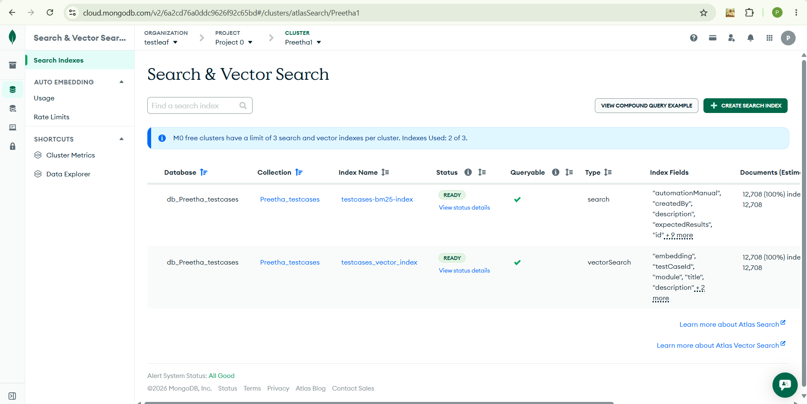
In the UI Converting Excel to JSON
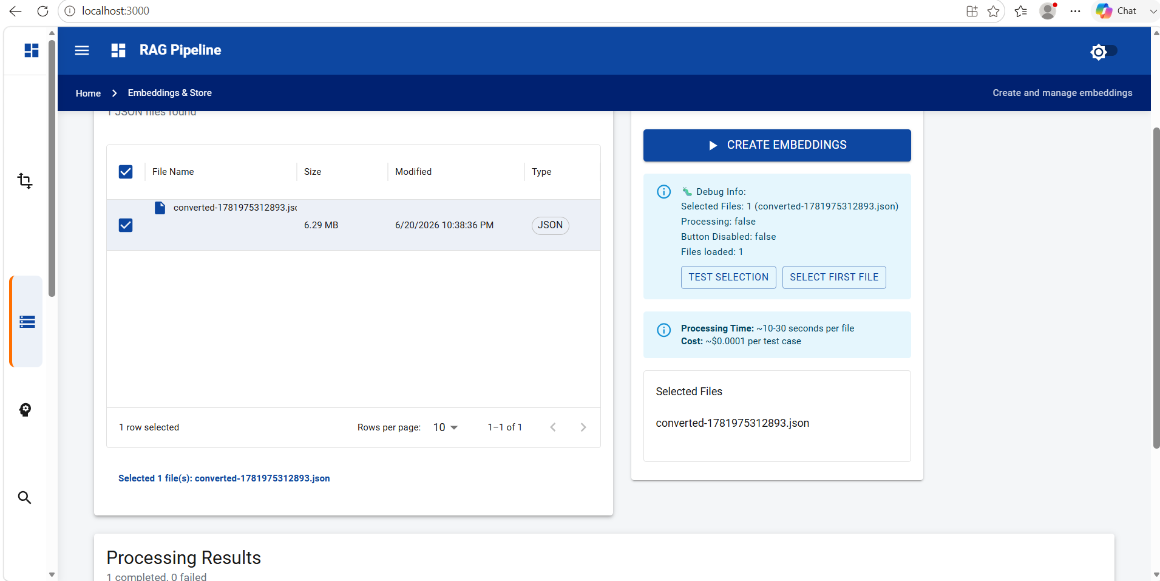
Showing API calls in the network Tab
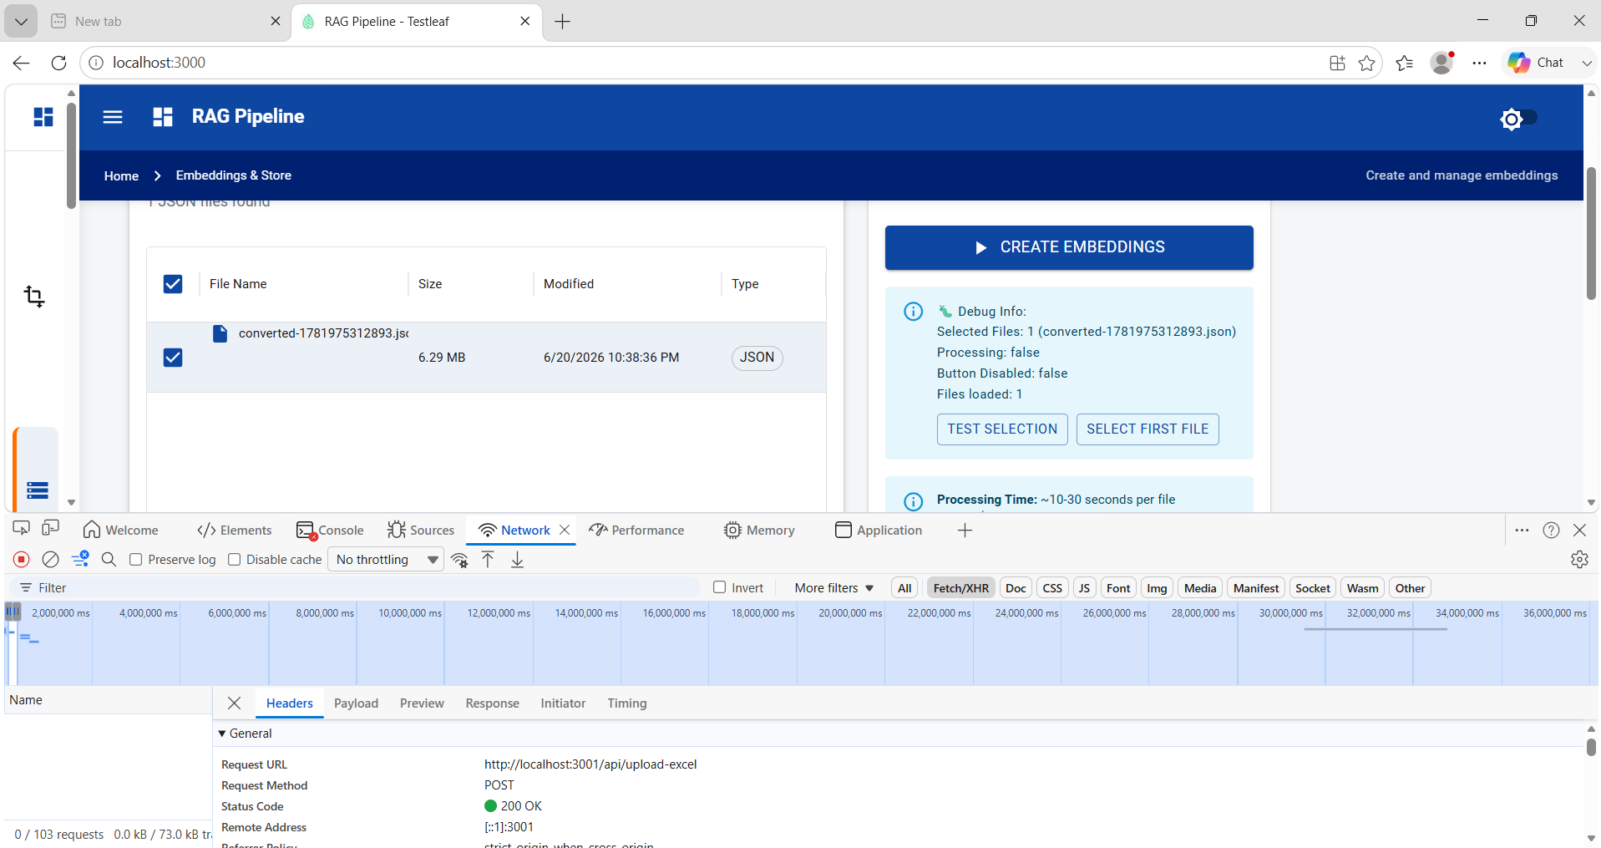

Status of Embeddings in Visual Studio code. In the side bar , you can see the files generated in the Embedding folder, data folder and Config files (which was given)
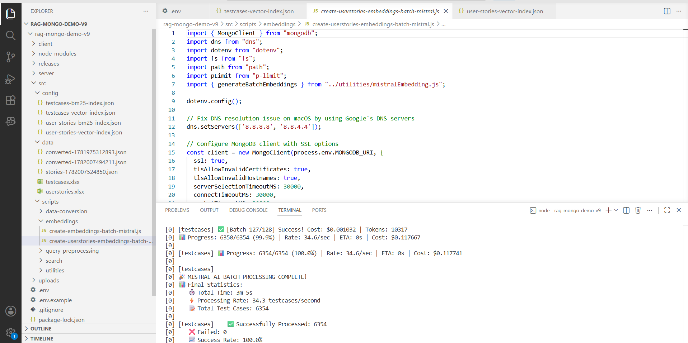
Ingestion testcases into the Mango DB:
